Chapter 5 Farrell Exercises

Exercise 1.

1. 5, 22, 5
2. 4, 6, 7
3. 6, 6
4. Goodbye

Goodbye

Goodbye

Goodbye

Goodbye

Goodbye

Goodbye

Goodbye

Goodbye

1. Hello

Hello

Hello

1. Adios

Adios

Adios

Adios

Adios

Adios

Adios

Adios

Exercise 5 Flowchart & Pseudocode.

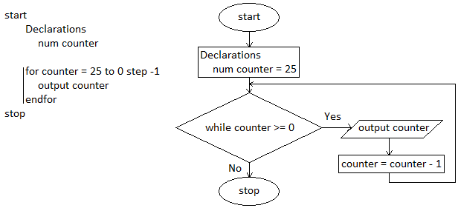

Exercise 6 Flowchart & Pseudocode.

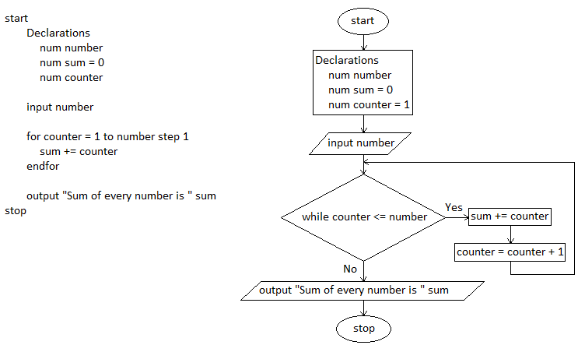

Exercise 7 Flowchart & Pseudocode.

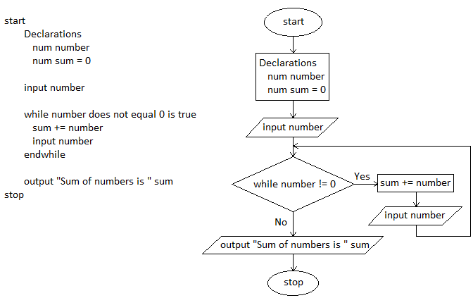

Exercise 11a.

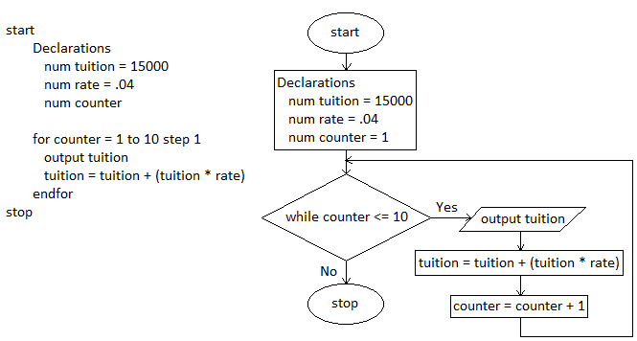

Exercise 11b.

